**Project Document: IntroVerse (Queens of Code)**

**Introduction**

*Aims and objectives*

We have developed a custom-designed website catered specifically to introverts with a deep interest in anime, reading and games. This digital platform aims to offer a unique and comfortable space for like-minded individuals to connect, share, and engage over their shared interests.

Our aims were to enable users to be able to join the website, look through content suggestions based on their interests to find something new to read, watch or play, and then discuss and communicate with others through a forum. We also had the objective of keeping it safe and highlighting the issues of loneliness and mental health, offering them signposts to resources. To try to keep on track we made a Gantt chart which shows the different phases of development and the important deadlines (figure 1).

*Roadmap of the project*

* Background
* Specifications and design
* Implementation and execution
* Testing and evaluation
* Conclusion

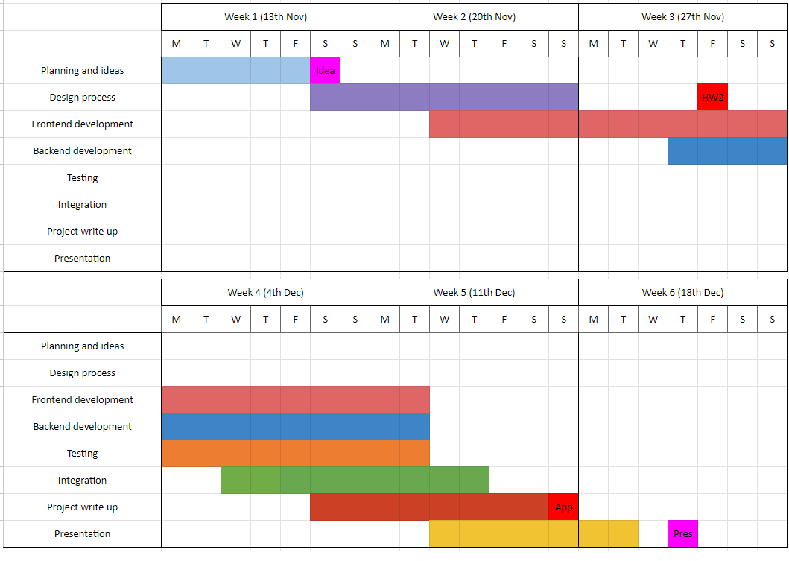

Figure 1: Gantt chart with important deadlines and each of the phases (transposed to fit better)

**Background**

Our website was inspired by the personal experiences of our team members, who are introverts themselves. We deeply understand the unique challenges introverts face in navigating life. This shared understanding is at the heart of our motivation to create a platform that addresses these specific needs.

*Mission*

At Introverse, we are dedicated to nurturing the mental well-being of introverts who cherish the worlds of anime, gaming and literature. We understand that finding a community where you can truly belong and express your passions can be a transformative experience. Our mission is to create an inviting digital haven where introverts can connect, share, and engage in meaningful conversations about anime, games and reading.

We strive to offer a platform that resonates with the unique needs and preferences of our audience, providing a space that feels like home. Here, every voice is valued, every interest is celebrated, and every individual is encouraged to embrace their love for anime, literature and gaming. Our commitment extends beyond creating a community; it's about fostering an environment where introverts can flourish, find like-minded friends, and feel empowered to explore their passions without any reservations.

In this journey, we are not just building a website; we are crafting a sanctuary where the beauty of solitude meets the warmth of togetherness, all centred around the shared love for anime, games and books.

*Target Audience*

Our primary audience includes introverts who find joy in anime, books and gaming. This platform is especially beneficial for those seeking a community where they can express their passions in a supportive and understanding environment.

Our website primarily focuses on a UK-wide audience, targeting individuals aged 18 and older. We have age verification measures in place.

**Specifications and Design**

*Design phase*

The design of the website follows a modern, user-friendly layout with distinct sections for various types of content, catering to an audience that values community and engagement. Here’s a summary justification for the design choices and the colour scheme.

Layout and Structure:

The website uses a card-based layout, which is a popular design choice for its clarity and ease of navigation. Each card or section is distinctly separated, allowing users to quickly identify different areas of content. There is a consistent header across all pages, which helps with brand recognition and provides a familiar navigation scheme for users as they move between pages.

Colour Scheme:

The homepage (figure 2a) utilises vibrant, inviting colours that give the site a friendly and energetic feel, encouraging user interaction and community feeling. The warm tones intended to making the space feel welcoming.

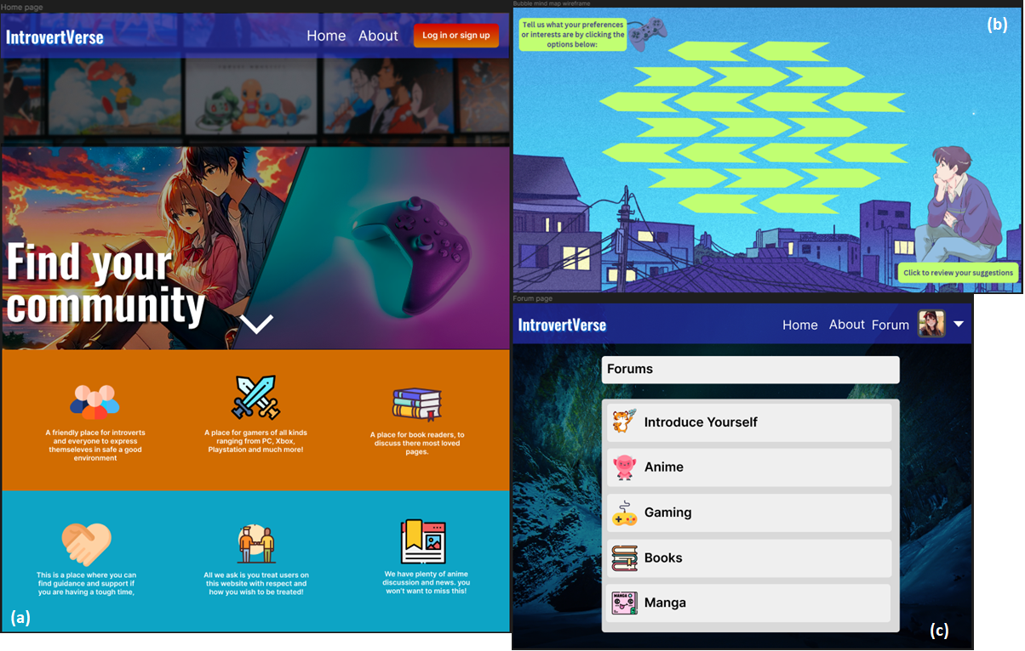

Figure 2: Some of our page designs, (a) home, (b) suggestions, (c) forum

The 'login' page, and the 'sign up' page (figure 3) use blue hues used in the buttons and headers to provide a professional and trustworthy feel, which is important for actions involving personal information. The contrasting pink for the "Sign Up" link on the login modal serves as a visual cue for new users to create an account, differentiating it from the primary action.

A neutral background colour is used for the modals to reduce strain on the eyes and ensure that the text and form fields are easily readable.

The about page uses a more monochromatic scheme with grayscale images, possibly to create a professional and serious tone when presenting information about the team and supporting charities.

The edit account page has a brighter background with nature imagery, which might be designed to convey a sense of growth and personalization, resonating with the user's experience of customising their profile.

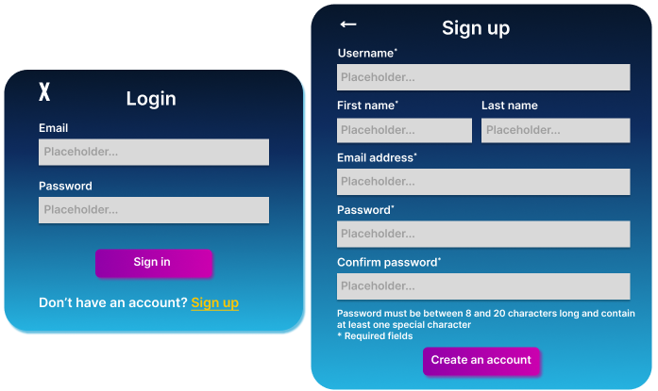

Figure 3: Initial designs for login (left) and sign up (right)

Typography and Icons:

The website uses modern and clean typography, which enhances readability and contributes to the site's overall sleek design.

Iconography is used to represent different interests or community categories, allowing for quick visual identification and adding to the aesthetic appeal.

Login page and Sign up page:

Login page and sign up page has clear, legible typography is used for both the headers and the form fields, maintaining a professional and accessible interface. Form fields are prominently styled with bold borders, making it easy for users to identify where to input their information.

Success Message:

The account creation success message uses a contrasting dark background with a bright text colour to signify the completion of the process, making it stand out and reinforcing the sense of achievement.

Notes and Error States:

The design includes notes for error states, an essential aspect of user experience design. Providing clear instructions on how to correct errors helps reduce user frustration and improve the overall efficiency of the interface.

Use of Imagery:

The images chosen for the homepage appear to be focused on community and shared interests, which is consistent with the website's theme of finding one's community.

The profile pictures on the about page are stylized silhouettes, which maintain user privacy while still personalising the page.

All of our designs on Figma can be found [here](https://www.figma.com/file/VuqbBCqHUIuWEIrdezfk2Z/Wireframes-group-1?type=design&node-id=0%3A1&mode=design&t=k9BJWwPI5Qqwx5Oj-1), we made both wireframes and high fidelity designs.

*Architecture and pages*

The final architecture of our website is shown in figure 4. The dashed lines are visible to all and the solid lines are only visible when you sign up and log in to the site. We thought it was important that the about page be visible to guests, as well as charities and mental health resource signposting.

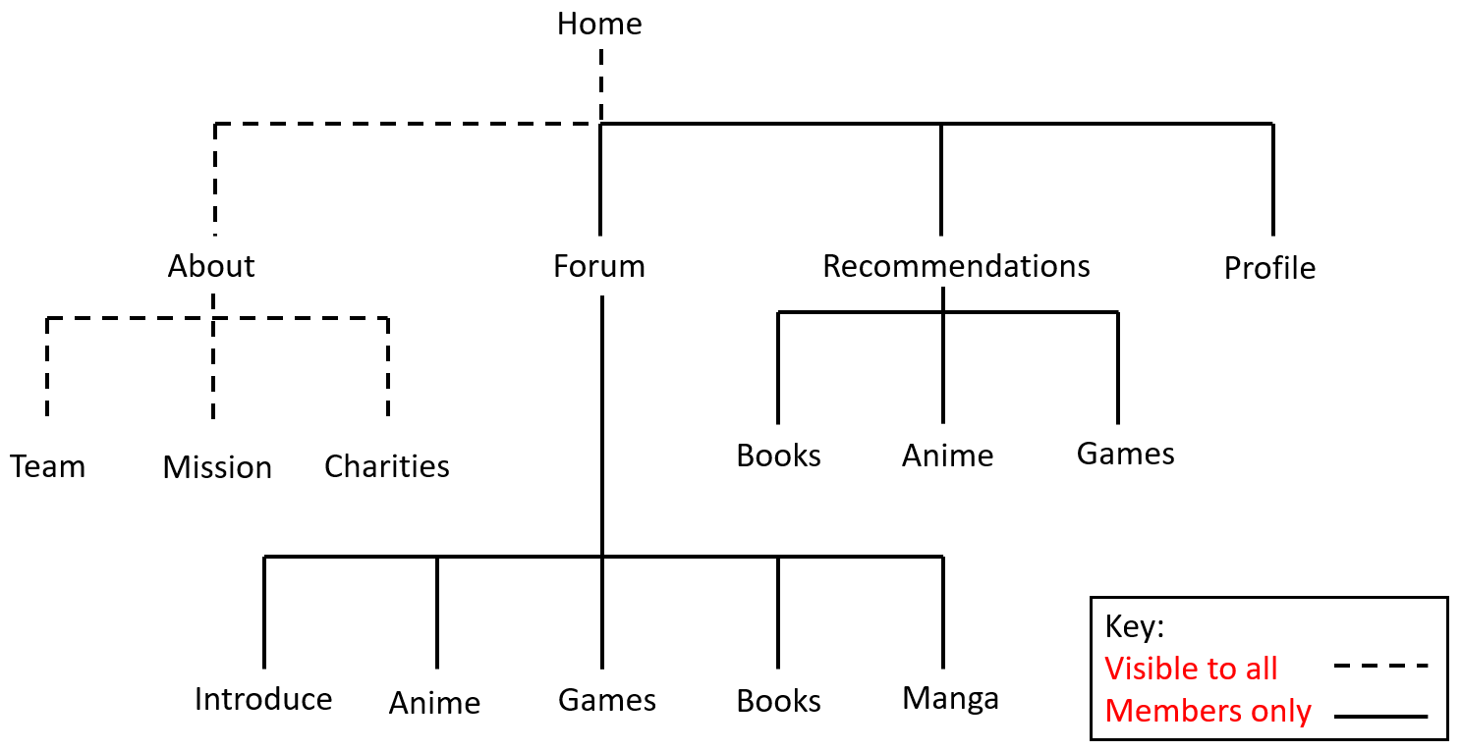

Figure 4: Diagram of the architecture of our website showing which routes are restricted (solid)

*Requirements*

Our requirements were:

* A sign up and sign in feature so a user can join the site and see the members only content
* Admin/moderator level accounts to be able to edit and moderate posts (we ran out of time to implement this)
* API for book, anime and game recommendations, categorise the genre and the type of the topic. User being able to choose what they are interested in to influence the result of the recommendation.
* Option to be able to post reviews or recommendations or start a discussion (became the forum page)
* Messages and user data needs to be saved to a database
* User friendly layout to capture the attention of the user
* Community guidelines and user feedback feature (didn’t get a chance to do this)
* Edit profile

**Implementation and Execution**

*Project approach*

To tackle this project effectively we utilised a spreadsheet to help us with planning and project management. In the beginning we used this to help figure out what everyone wanted to do with a SWOT analysis variation template (strengths, weaknesses, areas want to lead, areas want to shadow), to find out availability, gather ideas together, keep track of meetings and keep links of our resources (Figma, Trello, Jira etc). The spreadsheet grew over the course of the project and was useful for some bespoke tabs such as mapping the data movement through our app for each feature (figure 5) and Katalin’s amazing meeting minutes. The spreadsheet can be seen [here](https://docs.google.com/spreadsheets/d/1FBElJ-Ugojhys2-7k8QtyNIZ3OzQwUjolYq4MhxwVkM/edit#gid=1981884022).

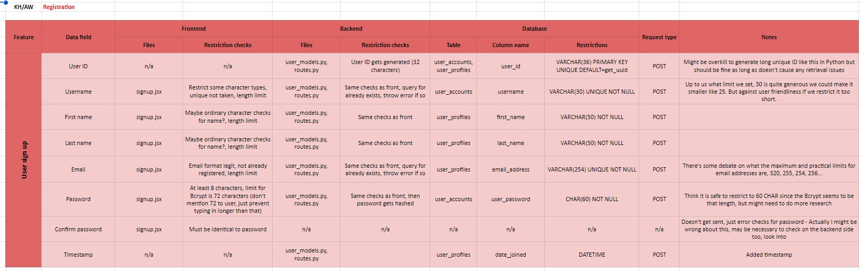

Figure 5: Data movement example for user sign up

We had weekly meeting sprints in each of the distinct phases (planning, design, development, project write up). We utilised agile tools such as Jira and Trello to help us assign tasks (figure 6). They were useful but in the final few dying moments of the project we resorted to bullet point lists because that was faster!

Figure 6: Trello board and custom labels

*Developmental approach*

We gathered everyone’s strengths and preferences and assignments were made accordingly. Everyone chose what they wanted to do and luckily we had a good balance of who wanted to do frontend and who wanted to do backend and data.

* Frontend - Angel, Haiying
* Recommendation API - Abbie
* Backend - Katherine
* SQL database - Katalin

*Angel (frontend lead)*

My role in the group is Lead Frontend Developer. I gave and assigned frontend tasks. I did this by managing it through slack and google sheets. Me and Haiying were the frontend Devs on our team. I also assisted in backend development making sure that all correct objects were created to connect db successfully to frontend of web application. I also made a database for posts in our website.

*Abbie*

In my role, I took charge of several tasks instrumental to our project's development. One key aspect was designing and implementing the suggestions input page, ensuring a user-friendly interface for gathering input. Additionally, I conducted extensive research to identify and integrate APIs within the React framework, aiming to enhance our project's functionality.

Building on this, I sourced relevant data encompassing books, anime, and games to populate our suggestions database. Utilising MySQL Workbench, I meticulously crafted the database structure, optimising it for efficient data storage and retrieval. Connecting this database to our codebase involved creating necessary indices and configuring JavaScript files.

In a collaborative effort, I contributed to our GitHub repository by adding essential files. To streamline user interaction, I crafted Routes.js files specific to each suggestion type, organising and enhancing our project's navigation system. However experienced some technical difficulties with our projects app and had to provide my code to the team instead so that they could implement this into the app and test it.

I delved into creating suggestion-related files for GET requests and establishing connections between images and suggestions via a suggestionsData file. Additionally, I played a role in designing an error page tailored for age restrictions, providing a template code that could be readily implemented and functionalized.

Another facet of my contribution involved updating the bio for our 'About Us' page, ensuring it accurately reflected the latest information. Collaboration was key in brainstorming and discussing design concepts with Angel, particularly focusing on enhancing the suggestions page for optimal user experience.

*Katalin*

Her responsibility was as well to meticulously document the meeting minutes in a detailed and comprehensible manner. This was crucial to ensure that team members who were unable to attend could still remain fully informed and up-to-date with the project's progress, decisions, and assigned tasks. Her focus was on clarity and thoroughness, striving to capture the essence of each discussion and decision made enabling all team members to stay aligned with the project's ongoing steps and developments.

To create the mission statement, which serves as a guiding element for the project. This statement was crafted to encapsulate the group’s goals and aspirations, ensuring the project remains aligned with these core values.

The responsibility of naming the group and the website also was her task to complete. The names chosen are not only memorable but also reflective of the project's essence and purpose. This decision was important in establishing the brand identity within the project.

User database development: On the technical front her role was to develop part of the user database using SQL. This task included designing the database schema to efficiently store and retrieve user data.

Final project documentation: capturing the evolution of the project, including major milestones. Documenting technical and strategic decisions, ensuring a comprehensive record for future reference.

The documentation of Homework 2 based on the design created by other group members was her task.

*Katherine (backend lead)*

In the beginning I set up the google spreadsheet to help with organisation. I helped with the designs of the login and sign up page.

My main focus was on the backend of our project. I wanted to utilise Python because it is my most familiar language and I’ve discovered during this course that backend/fullstack is definitely where I am most suited (but still very glad I stuck to fullstack specialisation). I’m most interested in Python so it had to be Python. I believe Django is a more utilised framework (and for a large project that would be the way to go) but since we had some experience with Flask already and the size of it wouldn’t be too daunting, it was the obvious choice.

I’m also interested in testing and I really wanted to make the most of that during this project… Well, unfortunately time got the better of me. I spent so much time learning how to utilise new libraries to me such as SQLAlchemy and Flask Restx, learn how to connect front to backend for the first, using Postman, how to make sign up and login functionality and also being completely new to React and not so familiar with JavaScript. So it was a big challenge. At least I was already somewhat familiar with classes in Python and I was very happy to get to use them. There was also a lot of pressure and a lot to build on my own. My stubbornness to try to implement complicated, more realistic solutions, got the better of me.

Together with Angel I connected the functionality of the login, sign up and logout frontend to the database. I added JWT session token functionality to the back and front end and used this to render what pages were visible on the navbar. I made models of all of our tables with SQLAlchemy (using the tables that Katalin, Abbie and Angel designed) and wrote the backend.

I helped write up the project document (all those years of research and report writing finally came in handy!)

*Haiying*

Haiying did some designs and wireframes in the design phase and helped with a bit of the frontend coding. Unfortunately she didn’t have much availability due to lots of outside commitments.

*Tools and libraries*

We used ReactJS as a library and we used several plugins such as axios, cors, express, mysql, react token auth. For the backend we used Express and Python Flask with MySQL database.

The backend consists of Python Flask, connected to a MySQL database. It uses flask-SQLAlchemy to connect to the database. SQLAlchemy allows tables to be created as class models (which were super fun to build). Then Flask-Restx has some very nice features for modelling the JSON, and lots of other features to make the API implementation much easier. Unfortunately I only learned about it in the last few days, if I did in the beginning would have got more out of it. Flask-jwt-extended handled the access tokens in the backend.

*Implementation challenges*

Abbie and API:

* Technical Issues: Throwing error's when attempting to run the react app after cloning making it difficult to run my own tests on my code or see if it works.
* Lack of prior knowledge on API's in react: time consuming to learn and research how to do this correctly.
* Issues with connecting database, had to configure and enable through shell.
* Unable to find public API with our requirements (genre): Had to make our own Database using MySQL Workbench to ensure it would be customised to our needs.

Angel:

I faced many difficulties such as filtering through lists getting data back from the useContext React hook. Connecting the API to frontend was difficult because this was totally new to me. I had to research couple hours to get it working.  I had issues with styling I found throughout development of this project I had to restyle many times before it looked good on a laptop screen.

Katherine:

There were challenges trying to implement the login feature in the beginning. I followed some guides and learned about a way to do server sided sessions with flask-session. After quite a lot of errors and reading I discovered that the parts it relied on didn’t work in newer versions so I had to learn about a new approach. Lots of time was spent learning and overcomplicating things but wanting to get them right. I learnt about all the joys of Python environments, pip install errors and the legend that is CORS. So many CORS problems, the only person who dislikes it more than me is Angel.

There were also challenges running the content API from Express (mostly because none of us were familiar with Express) so in the end we included it in the Flask one.

**Testing and Evaluation**

*Testing strategy*

The strategy was to test things as we went along. Testing with postman as building the routes, trying out error handling and debugging.

For unit testing the Python I created a TestConfig class to initialise the app with, as opposed to the standard ApplicationConfig. The difference was setting echo to false and specifying testing to true. This way no data would get deleted or added into the database. The functions of the test class included a create and tear down of the database, and then testing the various routes and methods. Unfortunately there was an issue initialising the app instance (circular imports) and I’m too unfamiliar to know where the problem was without much more research. I did try to refactor some of the code to make it work but I didn’t want to break it.  
I realise how important it is to write tests as you are writing the code. With more help I think testing would have been much easier.

I also tried testing React components, I started with sign up as this was an important one. Unfortunately I encountered an issue with the test not liking references to API calls. Again I’m much too unfamiliar with testing in Jest to find out how to solve that issue. Our React layout is quite complicated because Angel is such a wizard at React. So I found it difficult to find something suitable to test. We were unlucky that no one else was able to test.

*System limitations*

Frontend:

We had to drop a lot of ideas to make it through the deadline which was upsetting we couldn’t include them all. A feature we had to drop was allowing the user to edit their profile. The page had to be turned into a profile page instead. If I did the project again I would store all lists images in a different file because it can get quite messy.

API:

Abbie had to make her own API for the suggestions (because of lack of suitable public API) which meant that we were limited in the amount of options for each type and genre. Realistically we would have a much larger pool of options.

Backend:

There were lots of things that we couldn’t finish. I was setting up JWT token required routes on the front and backend. The navbar gets rendered to show only certain pages depending on logged in or out but I ran out of time to protect and renavigate from manually typing in the pages. I would also have added more extensive error handling (some routes are missing altogether) and of course more testing. We also really wanted to include the pictures for the content API that Abbie made. But with needing to write up this project we ran out of time to add them to the database.

**Conclusions**

Our group project faced significant challenges, notably the tight deadline and difficulties in communication due to varying schedules. We tackled these issues effectively by implementing weekly sprints and maintaining comprehensive minutes, enabling absent team members to stay informed and catch up efficiently. Our backend lead, Katherine, played a pivotal role by creating a comprehensive Google Spreadsheet accessible to all team members. This spreadsheet included a SWOT analysis for each member, aiding our planning phase by

allowing individuals to excel in areas they are most comfortable with. It also detailed data movement, recorded meeting minutes, outlined page architecture, and featured a Gantt chart that mapped out time frames, tasks, and resource allocations. This strategic approach greatly enhanced our project management and team coordination.

From a technical perspective, we encountered several challenges. Initially, we faced issues with our React application throwing errors post-cloning, which hindered our ability to conduct code testing effectively. This problem was compounded by our limited knowledge of API integration in React, making the learning and research process time-consuming and fraught with obstacles. Moreover, we struggled to find a public API that met our specific genre requirements. To address this, we decided to create a custom database using MySQL

Workbench, tailored to fit our unique needs. This solution not only resolved our immediate challenge but also provided us with a more flexible and customised data management system.

We've made remarkable progress on a positive note. Our website is meticulously designed, effectively fulfilling its purpose by enabling our target audience to log in and engage in discussions about their chosen entertainment. Throughout this project, our team has significantly developed our professional skills and gained practical experience in agile development methodologies.

We've also learned to utilise Trello for brainstorming design concepts and Kanban boards for tracking our progress. Importantly, individual team members have successfully overcome personal challenges by stepping out of their comfort zones embracing their true selves. This project was an extraordinary opportunity for us to discover our capabilities, demonstrating our commitment and the willingness to balance personal sacrifices with professional achievements. It's been a truly empowering journey, showcasing our

ability to maintain discipline and achieve our objectives.